Experiment No-5
Users receive booking confirmation
AIM:
To develop an online flight reservation website using HTML, CSS, and JavaScript to search flights and check seat availability. The system allows users to book and cancel tickets, view booking status, and print tickets.
Procedure:
- Create a flight search form using HTML.
- Design the interface using CSS.
- Use JavaScript to validate flight details.
- Display the flight booking confirmation.
- Test the webpage in a browser.
Sample Code:
<!DOCTYPE html>
<html>
<body>
<h2>Flight Reservation</h2>
<input id="from" placeholder="Departure City">
<input id="to" placeholder="Destination City">
<button onclick="searchFlight()">Search Flight</button>
<p id="result"></p>
<script>
function searchFlight() {
let f = document.getElementById("from").value;
let t = document.getElementById("to").value;
if (f && t && f.toLowerCase() !== t.toLowerCase()) {
document.getElementById("result").innerHTML =
"Flight search: " + f + " to " + t;
} else {
document.getElementById("result").innerHTML =
"Enter valid departure and destination";
}
}
</script>
</body>
</html>
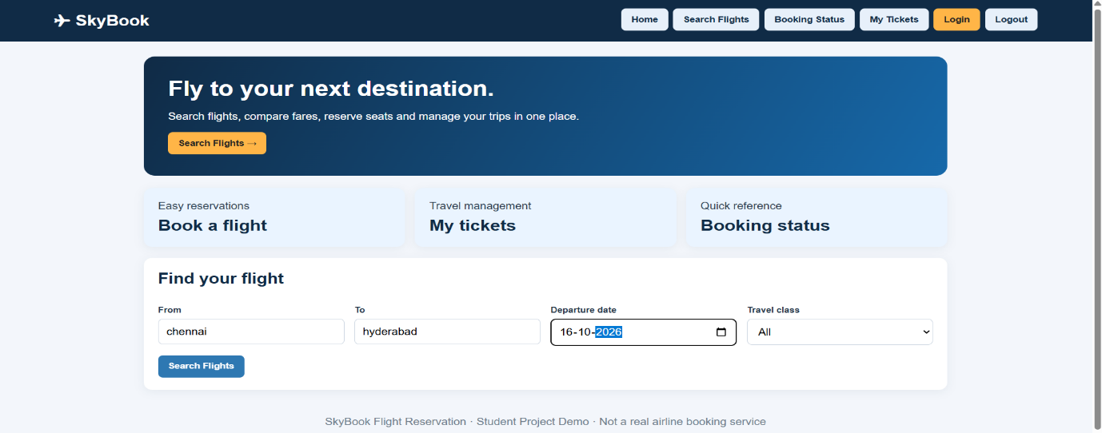
Result:
Thus, the flight reservation website was developed successfully to search flights, view available options, book tickets, check booking status, and print tickets.

